Module 2 Activity: File Plan and Folder Structuring
Use this screenshot depicting various files generated & assembled by a researcher to answer the questions below. 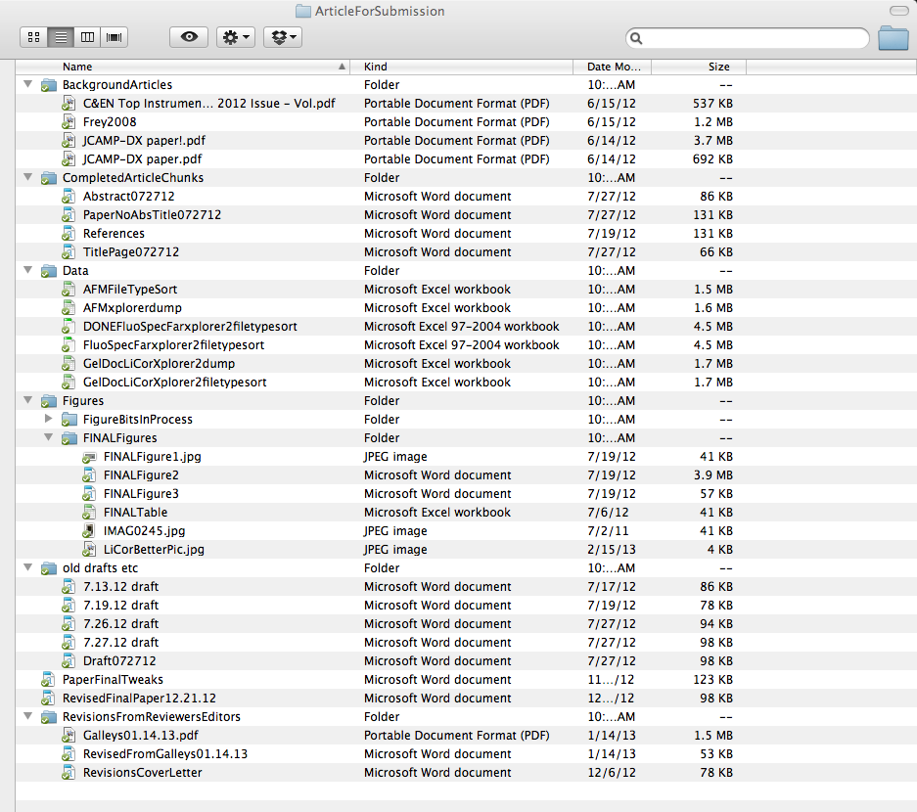
Questions:
1. Would you organize these files differently? If so, please briefly describe your method.
2. What suggestions would you make to this researcher about his or her file naming and organization practices?

